Subhan Bin Yousaf

481281

Section B

FOP Assignment 2

#include <iostream>

using namespace std;

int main(){

int a;

cout<<"Enter your score "<<endl;

cin>>a;

// checks to compare grade with standard

if (a>90 && a<100) {

cout << " Your grade is A " <<endl;

}

else if (a>75 && a<90) {

cout << "Your grade is B " << endl;

}

else if (a>60 && a<75) {

cout << " Your grade is C " << endl;

}

else if (a>45 && a<60) {

cout << "Your grade is D " << endl;

}

else if (a>0 && a<45) {

cout << "Your grade is F " << endl;

}

return 0;

}

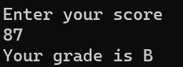

#include <iostream>

using namespace std;

int main () {

int c;

cout << " Enter your number " << endl;

cin>>c;

//checks to see if number is an even number

if (c % 2 == 0) {

// checks to see if a number is divisible by 5, if its even

if (c%5==0) {

cout<<"The number is even and divisible by 5"<<endl;

}

else {

cout<<"The number is even but not divisible by 5 "<<endl;

}

// checks to see if a number is divisible by 5 if not even

else if (c%5==0) {

cout << "the number isnt even but divisible by 5 "<<endl;

}

else {

cout << " the number is neither even nor divisible by 5"<<endl;

}

return 0;

}

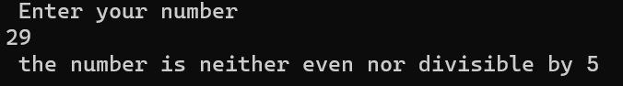

#include <iostream>

using namespace std;

int main () {

int d;

cout<< "enter your year "<<endl;

cin>>d;

//A leap year arrives every 4 years, with the last being in 2020, hence every year divisible by 5 is a

leap year

if (d%4==0) {

cout<< " This year is a leap year " << endl;

}

else {

cout<<" This year is not a leap year "<<endl;

}

return 0;

}

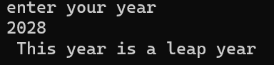

#include <iostream>

using namespace std;

int main () {

float a;

int b;

cout << "Enter the student's GPA " << endl;

cin>>a;

cout<< "Enter their attendance in % in class "<<endl;

cin>>b;

//compares the student's GPA and their attendance to compare if it exceeds the standard

if (a>3.5 && b>80){

cout << "The student is eligible for scholarship"<<endl;

}

else {

cout<<"The student is not eligible for scholarship"<<endl;

}

return 0;

}

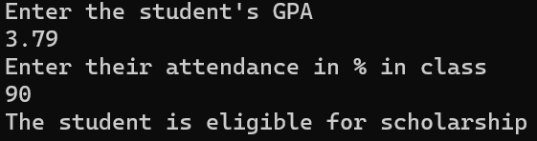

#include <iostream>

using namespace std;

int main () {

//taking a character value since we have to determine one single character

char d;

cout << " Enter your letter " <<endl;

cin>>d;

// Comparing whether the character input matches the Characters specified

if (d=='a' or d=='e' or d=='i' or d=='o' or d=='u') {

cout<<"The letter is a consonant"<<endl;

}

else {

cout << "The letter is not a consonant"<<endl;

}

